ESE 562_Project 3

Po Hsu Chen, 448031

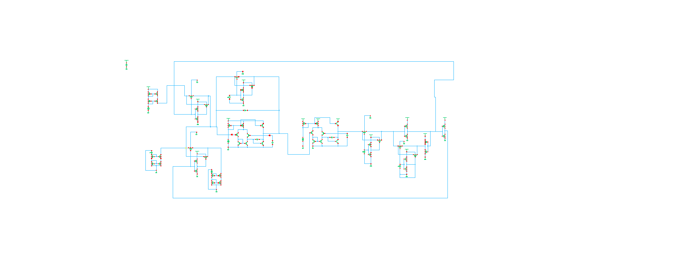System level architecture with component values (C, Io, CLK, VREF, VCMP)

Vdd – Vdc(3V) – gnd

Amplifier Implementation

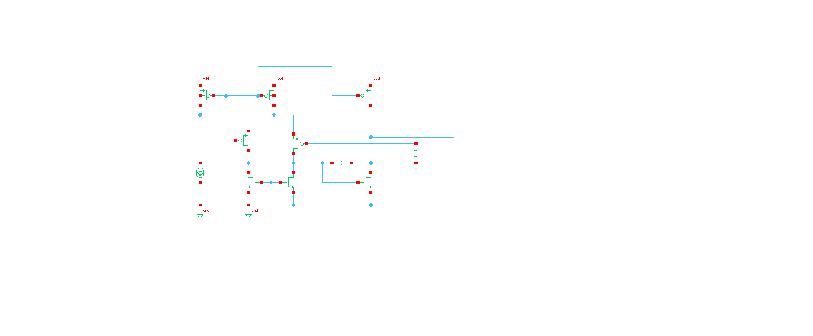

Implementation

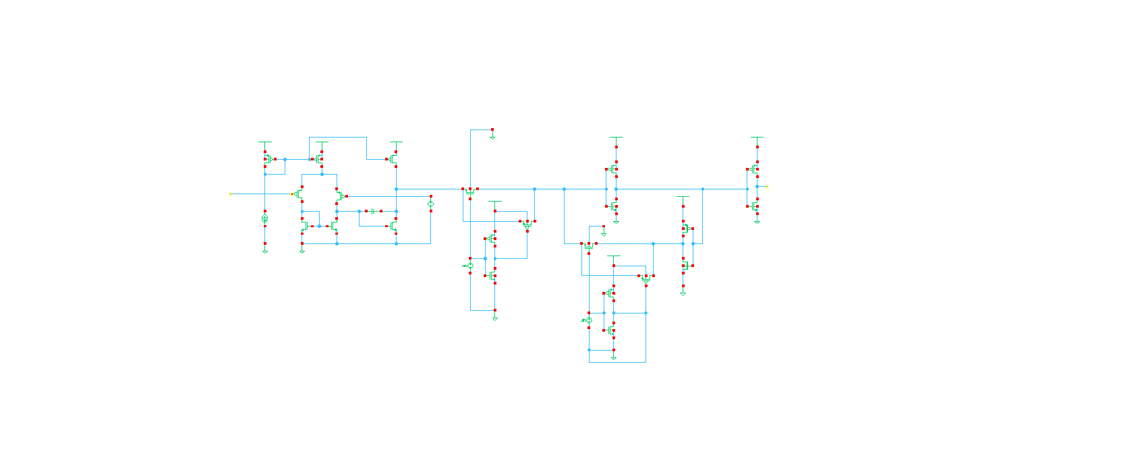

**CMOS Switch**

**Current Source and Sink**

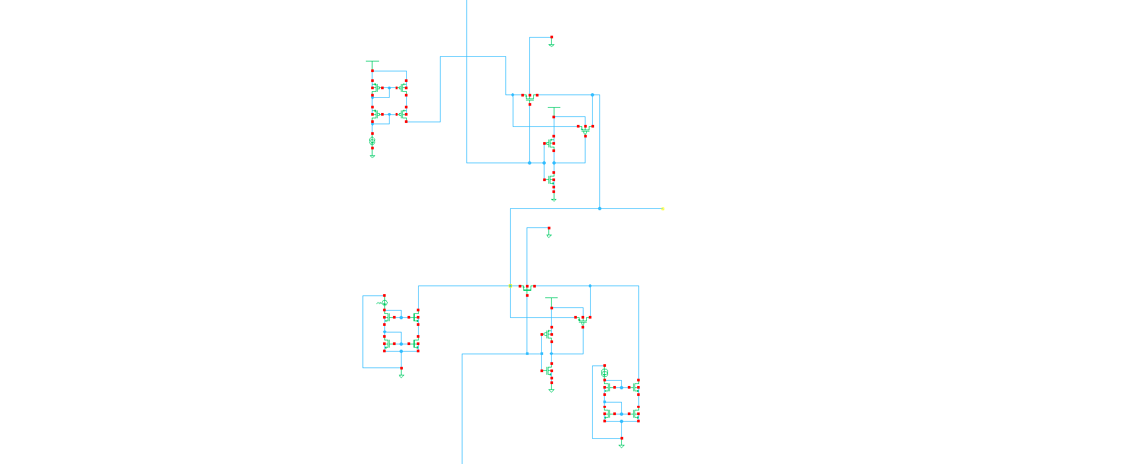

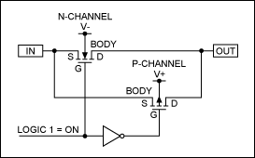

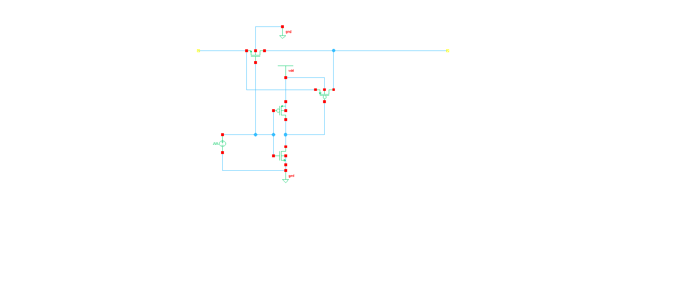

**Latched Comparator**





Output of the modulator and voltage V